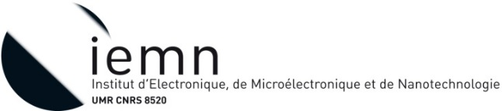
Engineer Position:
Development of microfluidics technologies for cellular research
Context:
The ability to conduct quantitative studies on cells placed into highly controlled environments is a pre-requisite to better understand the biological processes underlying metabolic disorders.
This project sits at the junction between microfabrication and biology.
On the biology side, we wish to investigate the role played by the circadian clock in muscle regeneration. Circadian rhythm are known to play a significant part in several key aspects of our physiology by optimizing our metabolism to the various task it must typically accomplish at specific times of the day. The disturbances induced by our lifestyles on this clock have been shown to produce a wide range of diseases. This project will investigate the interplay between the metabolism of specific muscle cell lines and a key component of our circadian clock: Rev-erbα In particular, we will try to address the question: does the time of injury or the time of stem cell injection plays a part in the subsequent healing process?
This study will be conducted using microfluidic chips to enable an extensive control of every aspects of our cell culture. The position will take place at IEMN where a world class clean room is available for micro/nanofabrication and taking advantage of the newly build biomicrofluidics lab. A first step will consist in designing and producing a microfluidic chip suited to muscle cell growth. Subsequent steps will couple this chip with others to enable co-culturing and controlled communication between different cells types. The microfluidics chips will be produced, depending on the required complexity, either by using soft lithography technique (PDMS) or a glass-silicon-glass technology developed at IEMN. The cell culture in these chips will be monitored by optical microscopy. The main challenges of these tasks will be on the one hand to produce an as biomimetic environment as possible for the cells to develop in and, on the other, to manage interaction/communication between the various biological components known to interact in vivo to regulate muscle regeneration.
The project is supported by CPER Photonics for Society. The work aims at designing and fabricating microfluidics systems in the IEMN cleanroom. The work is developed in collaboration with biologists. The selected candidates participate to a project in the field of biology that involved again stem cells but with the purpose to understand their effect in the regeneration of muscles. This project is financially supported by the Region Nord-Pas-de Calais-Picardie. The partners are PhLAM UMR8523 laboratory and the INSERM U1011 laboratory.

What we are looking for:
We are looking for a motivated individual who wants to work at the interface between biology and microfabrication. We are ideally looking for a candidate with a proven track record of working at the interface between biology and other fields and able to interact with biologist and non-biologist alike. While having a background in microfabrication techniques would be an advantage, the candidate will be fully trained at IEMN in this regard.
Duration: 12 months appointment available from 1st September 2016 and the candidate must be able to start before the 30th of September 2016.
Salary: 1750€ net/month.
Location: Institut d’Electronique, de Microélectronique et de Nanotechnologie – IEMN, Villeneuve d’Ascq (F)
Contact: Please send your resume and a motivation letter by email to vincent.senez@isen.iemn.univ-lille1.fr / Anthony.treizebre@univ-lille1.fr
V. Senez / A. Treizebre
IEMN – UMR-CNRS 8520
Cité Scientifique – Avenue Poincaré BP 60069
VILLENEUVE D’ASCQ CEDEX, F-59652 France
www.iemn.univ-lille1.fr
Phone : +33 (0)3 20 19 78 55 / +33 (0)3 20 19 79 37

