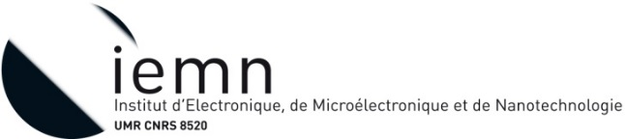
Engineer Position: Development of microfluidics technologies for cellular research

Background: Cancer Stem Cell (CSC) are a subpopulation of tumor cells displaying self-renewal, tumorigenicity and multi-lineage differentiation capacities. CSC are also suspected to be involved in the metastatic cascade resulting in the growth of distant secondary tumors that often account for the cancer-specific death. Researchers and oncologists see in CSC an explanation as to why cancer may be so difficult to cure. Our project aims at investigating the glycome of breast cancer stem cells, using a combination of transcriptomic, flow-cytometry, glycomic experiments and microfluidics, in order to identify glyco-markers (genes and/or glycans) of stem cells. The function of these glyco-markers in CSC biology will be assessed both in vivo and in vitro using relevant genetically modified cell lines. Particular emphasis is put on the elucidation of CSC-supported metastasis using in-house developed microfluidic devices.
Description of work: The project is supported by INCA and involved two partners: INSERM U908 laboratory (cell plasticity and cancer) and the CNRS UMR8520 laboratory (IEMN-Nanotechnology), both located on the campus of the University of Lille in Villeneuve d’Ascq (France). The work aims at designing and fabricating microfluidics systems in the IEMN cleanroom. The work is developed in collaboration with biologists. The selected candidates will also participate to a second project in the field of biology that involved again stem cells but with the purpose to understand their effect in the regeneration of muscles. This second project is financially supported by the Region Nord-Pas-de Calais-Picardie. The partners are PhLAM UMR8523 laboratory and the INSERM U1011 laboratory.
Duration: 12 months appointment available from 1st March 2016 and renewable
Salary: ~2200€ net/month
Location: Institut d’Electronique, de Microélectronique et de Nanotechnologie – IEMN, Villeneuve d’Ascq (F)
Requested qualification: Ph.D. in micro-engineering science with strong experience in cleanroom fabrication.
Contact: Please send your resume and a motivation letter by email to vincent.senez@isen.iemn.univ-lille1.fr
V. Senez
IEMN – UMR-CNRS 8520
Cité Scientifique – Avenue Poincaré BP 60069
VILLENEUVE D’ASCQ CEDEX, F-59652 France
www.iemn.univ-lille1.fr
Phone : +33 (0)3 20 19 78 55

