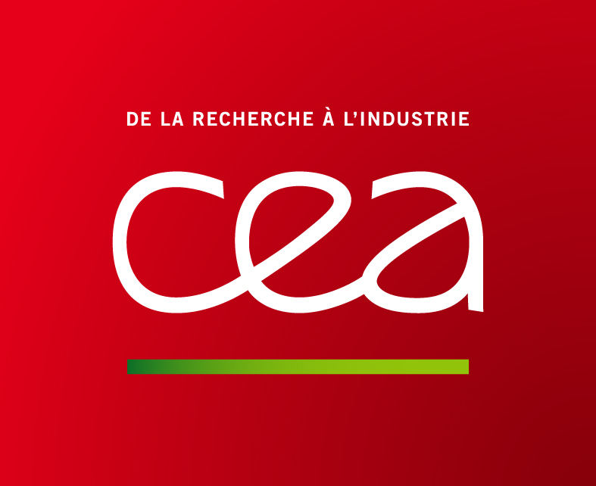
Job offer

Post-Doctoral Position in microfluidic for cell screening and therapy

About CEA-Leti
Leti is an institute of the Commissariat à l’Energie Atomique et aux Energies Alternatives (www.cea.fr), a French research-and-technology organization with activities in energy, IT, healthcare, defence and security. Leti is focused on creating value and innovation through technology transfer to its industrial partners. It specializes in nanotechnologies and their applications, from wireless devices and systems, to biology, healthcare and photonics. NEMS and MEMS are at the core of its activities. An anchor of the MINATEC campus, CEA-Leti operates 8,000-m² of state-of-the-art clean room space on 200mm and 300mm wafer platforms. It employs 1,400 scientists and engineers and hosts more than 190 Ph.D. students and 200 assignees from partner companies. CEA-Leti owns more than 1,700 patent families.
For more information, visit www.leti.fr.

Within the Division of Technology for Biology and Health, the Biosystems on chip Division develops new microfluidic device. In collaboration with Grenoble Hospital and the Life Science Department at CEA Grenoble, we are developing new microsystems for prostatic and pancreatic cells encapsulation. Concerning prostatic cells encapsulation, the aim is to produce 3D cells models for drug testing. Currently, only 20 % of drugs that reach clinical trials continue to Phase II. While the pharmaceutical industry invested 100 billion US dollars in R&D last year, 75% of it corresponded to failure. The main reason behind this unsustainable situation is the poor quality of the models used to test drug candidates before clinical trials. Toxicity and efficacy are tested on human cells grown in-vitro in 2D formats and in living animals, both incapable of reproducing the human physiology with accuracy.
In this project, cells are prostate cancer cells. They will be encapsulated and grown in the capsules in order to develop in 3D space (as opposed of the growth in petri dish where they develop in 2D). The purpose is to do a genomic high-throughput screening for studies of prostate cancer.
Concerning the pancreatic cells encapsulation, the aim is to treat type I Diabetes. In some cases, the only option for people suffering from type I Diabetes is to receive a pancreatic graft. This is associated with long, expensive and restrictive immuno-suppressive treatments. One alternative is to graft encapsulated cells in order to limit or to suppress these immuno-suppressive treatments.
Both applications have in common the cells encapsulation. Today’s encapsulation technologies involve many manual steps leading to poor reproducibility in batch to batch production. At CEA-Leti we decided to implement a new cell encapsulation system ensuring high quality encapsulation and batch to batch reproducibility.

Mission
The core of this project is to implement new functions and new process in the existing cell encapsulation device and implement a robust, industry-compatible microfluidic platform for the generation of cell-laden gel microbeads and the integration of such platform with automated fluid handling and cell culture equipment. The candidate will also develop and characterize a new microfluidic device for cell sorting. These steps involved the set-up of a dedicated bench, the design and conception of microfluidic chips. Experiments on living cell will be performed. Cell viability and functionality will be performed either on primary cell culture or cell lines.

Candidate Profile
The candidate must speak English (and/or French) and have good communication skills as he/she will have to work and report inside a collaborative team.
He/She will possess a background in the field of physics/engineering, microfluidics, physics/chemistry, Bioengineering, soft material characterization. Knowledge in cell culture would be a plus. The candidate will have an experimentalist profile and be highly motivated by multidisciplinary project.

Starting date: 1/05/2015
Duration: 12 months, but good prospects for continuing employment up to 2 years.
Candidate should send CV, cover letter and recommendations to Dr Florence Rivera and Dr Frederic Bottausci.

Contacts
Dr Florence Rivera florence.rivera@cea.fr
Dr Frederic Bottausci frederic.bottausci@cea.fr

